

**2024**

# **Table of Content**

­­

* **Table of Contents**
* **Introduction …………………………………………………… 01**
* **Objectives of the Project …………………………………… 02**
* **Problem Statement ………………………………………… 03**
* **Functional Specification …………………………………… 04**
* **4.1 User Roles**
* **4.2 Features**
* **Hardware and Software Requirements ………………… 05**
* **Standards Plan ……………………………………………… 06**
* **Documentation ……………………………………………… 07**
* **Database Design …………………………………………… 08**
* **8.1 Entity-Relationship Diagram**
* **8.2 Database Tables**
* **Developer Guide …………………………………………… 09**
* **9.1 Setting Up the Development Environment**
* **9.2 Code Structure and Best Practices**
* **User Guide ………………………………………………… 10**
* **10.1 For Parents**
* **10.2 For Admins**
* **10.3 For Hospitals**
* **Task Sheet ………………………………………………… 11**
* **FAQs ………………………………………………………… 12**
* **System Maintenance Guide …………………………… 13**

# **Certificate of Completion**

This is to certify that  **Sulainman,** have successfully completed their ACCP Prime 2.0

Semester II E-Project.

Submitted to: **Aptech Computer Education**

On

**September 24st, 2024**

# **Acknowledgement**

1. First and foremost, we would like to express our heartfelt gratitude to Almighty Allah for granting us the strength and ability to successfully complete the Child Vaccination Management System project.
2. We extend our special thanks to our teacher**, Sir Asif Ahmed Khan**, whose invaluable guidance and support played a pivotal role in the development of this project. His insights and encouragement helped us navigate various challenges and expand our knowledge in numerous areas.
3. Lastly, we would like to thank our parents and friends for their unwavering support and motivation, which helped us meet the project's deadlines. We also appreciate the assistance of the I-Project team from Aptech Head Office for their valuable guidance during this process.
4. We sincerely hope that this project provides all the necessary information and tools to benefit its users. Suggestions and feedback for improvements will be warmly welcomed and acknowledged.

# **Problems Statement:**

1. In today's critical healthcare environment, managing child vaccinations effectively is essential for public health. Parents, hospitals, and healthcare providers often face significant challenges in tracking vaccination schedules, maintaining accurate records, and ensuring timely appointments. Traditional methods, such as manual record-keeping and phone-based appointment systems, are not only time-consuming but also prone to errors, leading to missed vaccinations and communication gaps between stakeholders.
2. The objective of this project is to develop a Child Vaccination Management System (CVMS) that automates and streamlines the vaccination process. This system will facilitate real-time tracking of vaccinations, appointment scheduling, and effective communication among parents, healthcare providers, and administrators. By reducing the potential for errors and improving the efficiency of vaccination management, the CVMS aims to enhance vaccination rates and overall child health outcomes.

# **Functional Specification**

# **The Web site is to be created based on the following requirements.**

1. **Home Page**
2. The Home Page will feature:
3. Proper sections highlighting key information about the system.
4. Engaging graphics that reflect the theme of child health and vaccination.
5. A suitable logo representing the CVMS.
6. **Navigation Links**
7. The Home Page will include the following navigation links:
8. **Home**: Redirects to the main page.
9. **Vaccination Management**: Details the functionalities of the vaccination tracking system.
10. **Services**: Outlines the services offered to parents, hospitals, and administrators.
11. **Login Form**: Allows users to access their accounts securely.
12. **User Interface Design**
13. The design will ensure a user-friendly experience, with intuitive navigation.
14. Uniformity in color combinations will be maintained throughout the site for a cohesive look and feel.
15. **Vaccination Management**
16. Detailed information about the vaccination tracking features, including how parents can manage their child's vaccination schedule and access records.
17. **Services Section**
18. A comprehensive overview of services provided, such as appointment scheduling, reminders, and reporting tools for users.
19. **Login Form**
20. A secure login form for parents, healthcare providers, and administrators, featuring:
    1. Username and password fields.
    2. "Forgot Password?" functionality.
21. **Admin Panel**
22. An Admin Panel will include functionalities for:
    1. Managing user accounts (add, update, delete).
    2. Viewing and managing vaccination details.
    3. Scheduling vaccinations and generating reports.
    4. Managing vaccine inventory.
23. **Tester Panel**
24. A Tester Panel will provide options for:
    1. Testing various functionalities of the system.
    2. Generating test cases and reporting bugs or issues.

# 

# **Hardware and Software Requirements**

**Hardware**

* A minimum computer system that will help you access all the tools in the courses is a Pentium 166 or better
* 128 Megabytes of RAM or better

**Operating System**

* LINUX / Windows 2000 Server (or higher if possible)

**Software**

* PHP
* MySQL
* Apache

**Project Synopsis**

1. We have developed a comprehensive and innovative Child Vaccination Management System (CVMS) designed to streamline and enhance the management of child vaccinations. This web-based solution caters to parents, healthcare providers, and administrators, ensuring efficient tracking and scheduling of vaccinations.
2. **Key Features**
3. **User-Friendly Interface**: The CVMS includes an intuitive and accessible interface for all users, making it easy for parents to manage their child's vaccination schedule and access important records.
4. **Admin Panel**: The Admin Panel empowers healthcare administrators to manage user accounts, oversee vaccination records, and generate reports. This centralized control enhances the overall efficiency of the vaccination process.
5. **Secure Login**: Parents and healthcare providers must log in to access their respective interfaces, ensuring data security and personalized experiences.
6. **Vaccination Approval Workflow**: The system allows healthcare providers to approve or reject vaccination requests. Upon assessment, if a vaccination is approved, it is recorded in the 'Approved' section, while rejected requests are documented in the 'Rejected' section. This clear distinction helps in tracking and managing vaccination statuses effectively.
7. **Notifications and Reminders**: Automated notifications keep parents informed about upcoming vaccinations and appointments, reducing the likelihood of missed vaccinations.
8. **Reporting Tools**: Comprehensive reporting features enable administrators to analyze vaccination data, track rates, and manage inventory, contributing to improved public health outcomes.

# **Website Features**

1. **Comprehensive Vaccination Catalog**
2. A detailed catalog showcasing available vaccines, including descriptions, benefits, and schedules.
3. **Appointment Management**
4. Users can easily schedule, reschedule, or cancel vaccination appointments through an intuitive interface.
5. **Real-Time Tracking**
6. Parents can track the vaccination status and history of their children in real-time.
7. **Automated Notifications**
8. Automated reminders are sent to parents for upcoming vaccinations and appointments, ensuring timely participation.
9. **User Roles and Access**
10. Different user roles (parents, healthcare providers, administrators) with tailored access and functionalities for each role.
11. **Reporting and Analytics**
12. Comprehensive reporting tools for administrators to analyze vaccination rates, appointment statistics, and inventory levels.
13. **Secure Login System**
14. A secure authentication system for users to protect sensitive health information and personal data.
15. **Communication Portal**
16. Built-in messaging system for efficient communication between parents and healthcare providers regarding vaccination updates and follow-ups.
17. **Feedback and Support**
18. A section for users to submit feedback or request support, fostering continuous improvement and user satisfaction.
19. **Educational Resources**
20. Access to resources and information about vaccination importance, procedures, and FAQs to educate parents and caregivers.

**ADMIN LOGIN**

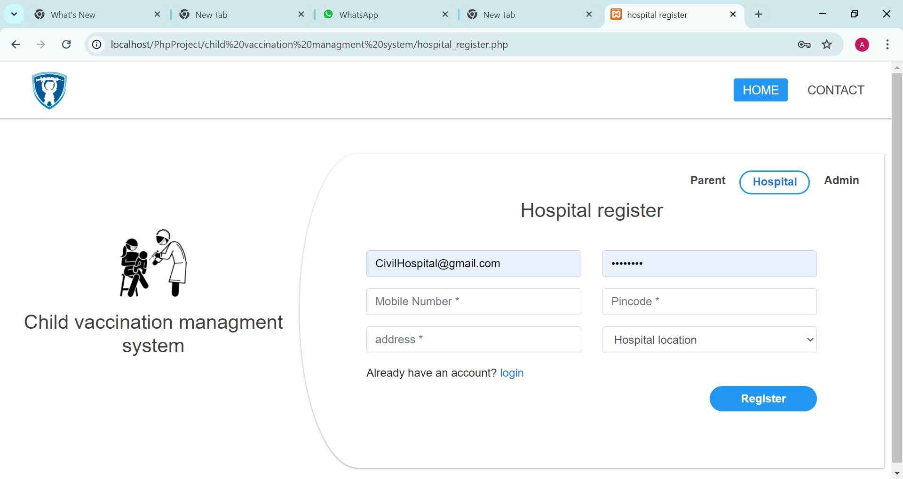

*ADMIN HOME*

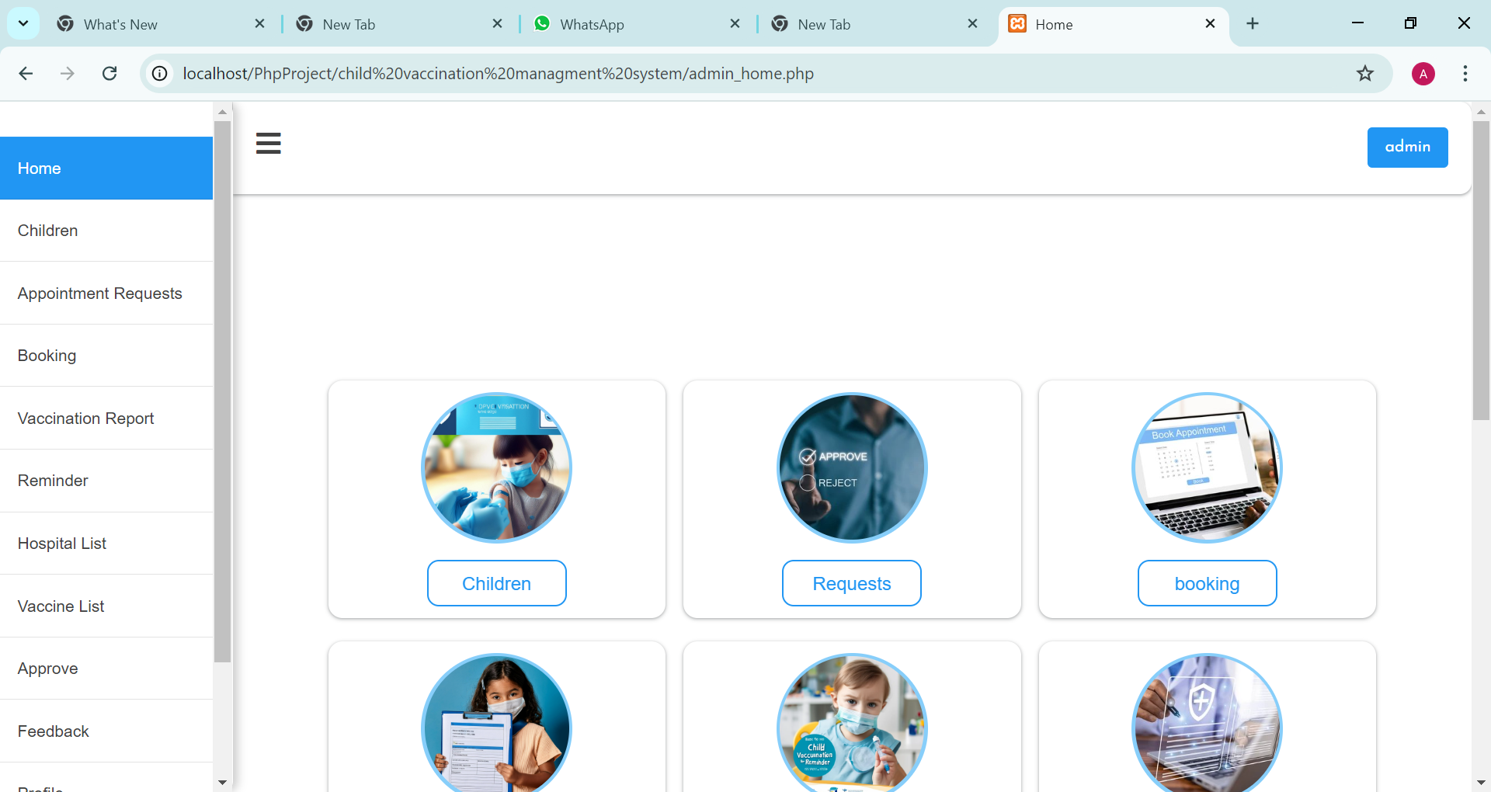

ADMIN APPOINMENTS REQUEST

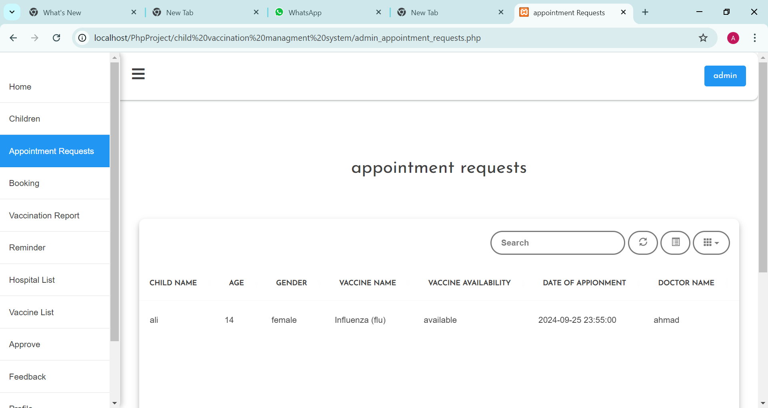

*PARENT PROFILE*

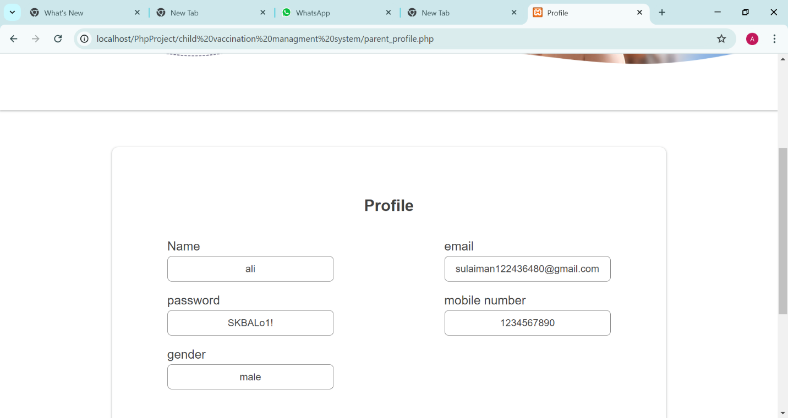

:

*HOSPITAL HOME*

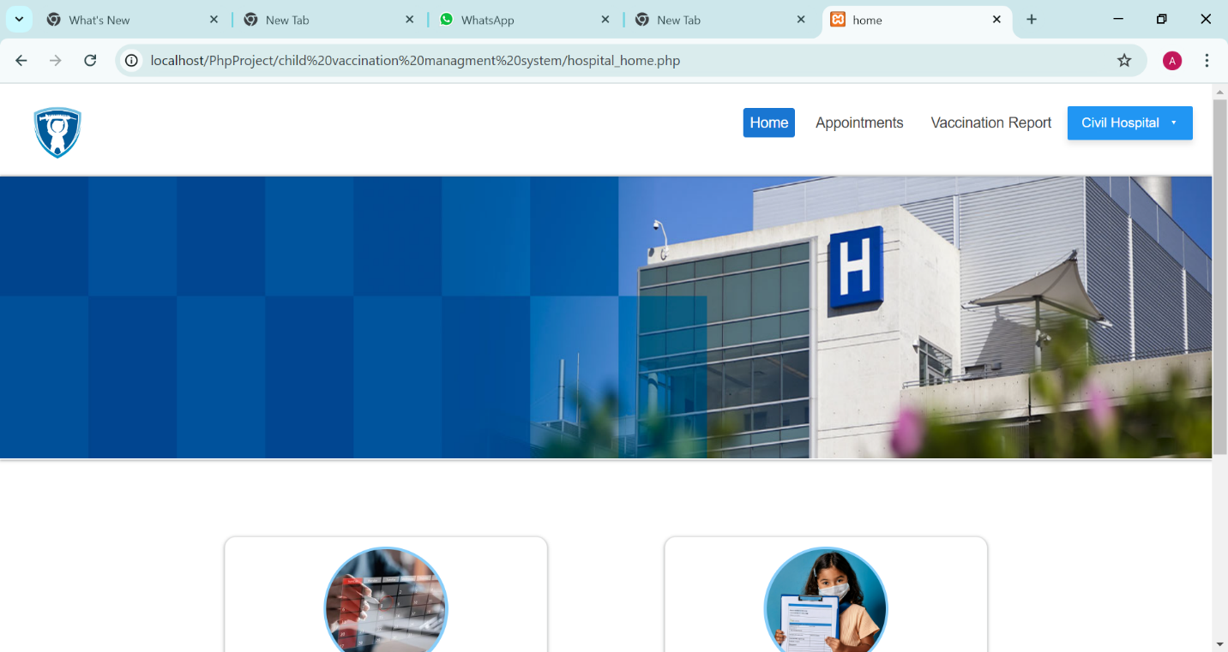

*DATABASE*

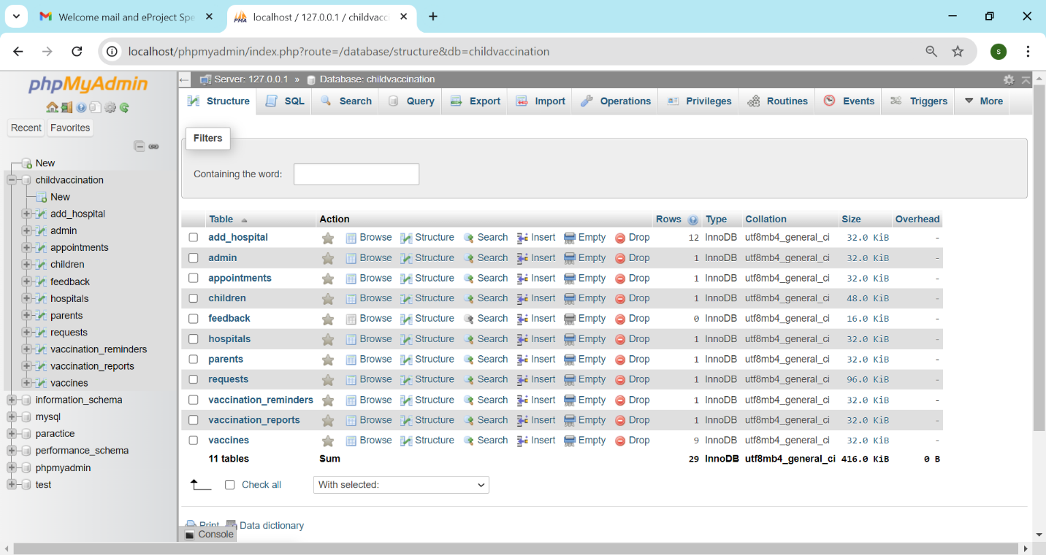

*ER DIAGRAM*

